Discovering Nova Scotia 3/4 Rossi
Get back to question 16
- Follow this Google Maps link.
Look through the photos of various places in Halifax. List any places you’ve been or places you would like to visit.

Get back to question 9
- Using the map find the 3 yellow national parks. List them here

1.
2.
3.

Get back to question 4
- There are many First Nations People who were some of the original people in Nova Scotia. From this map choose one community.
Type it here ________________

- What is the name of the location, of the community you chose in question 3? Use the community map in question 3 and the map in question 2.
(There’s a link to return to question 4 at the end of question 2.)

__________________________________

- How and why did the Mi’ kmaq people move during the winter and summer? What did they eat? Jot down any notes here

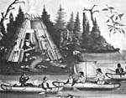
(click on image)

Remember for share time.
- What is Africville?

Who was the last person to move from Africville?__________________________

(There’s a link to return to question 6 at the end of the Africville slide.)
- One of the symbols of Nova Scotia is its official flower. To find out what it is go here and complete the puzzle.
Type the name of the
flower here ______________
- Watch this Nova Scotia Tour.
Jot some notes…

and remember 2 facts for share time later.
- Return to question 1 and use Google Maps. Type in the name of your school. See if you can find your street from there.

(There’s a link to return to question 9 at the end of question 1.)
- Watch and Learn about the Osprey

Turn and talk with a partner and share at least
one interesting fact you learned.

- Step 1- Open Paint on your computer.

Step 2- Draw a picture of an Osprey.

Step 3- Cut and paste the picture into here.

For more info go here.

- What do you think this is an image of?

_______________________________

Now that you’ve guessed go back to the image and click on the link to find out what happened in Louisburg in the year 1732-1733.
Type it here

Check out this map of Louisburg.
- Using ‘shapes’ on your computer try to create the Nova Scotia Flag. Insert your shapes here

Compare your flag to this one.

- Now compare the flag of Nova Scotia to the Scottish Flag. Describe what you notice below.

Why do you think the flags look this way?

Check your answer here.
- Who is this?
_______________________

Check your answer here.
Learn more about him here.

- Return to the picture at the top of the page.

Click on the picture and see what was found in the harbour recently.

__________________________________

Read the article and describe why its important that boaters be careful of this creature in the water.

Aaron “Pa” Carvery surrounded by rubble on the site of his Africville home. Most residents left between 1964 and 1967. Pa Carvery, the last Africville resident, held out till January 2, 1970.

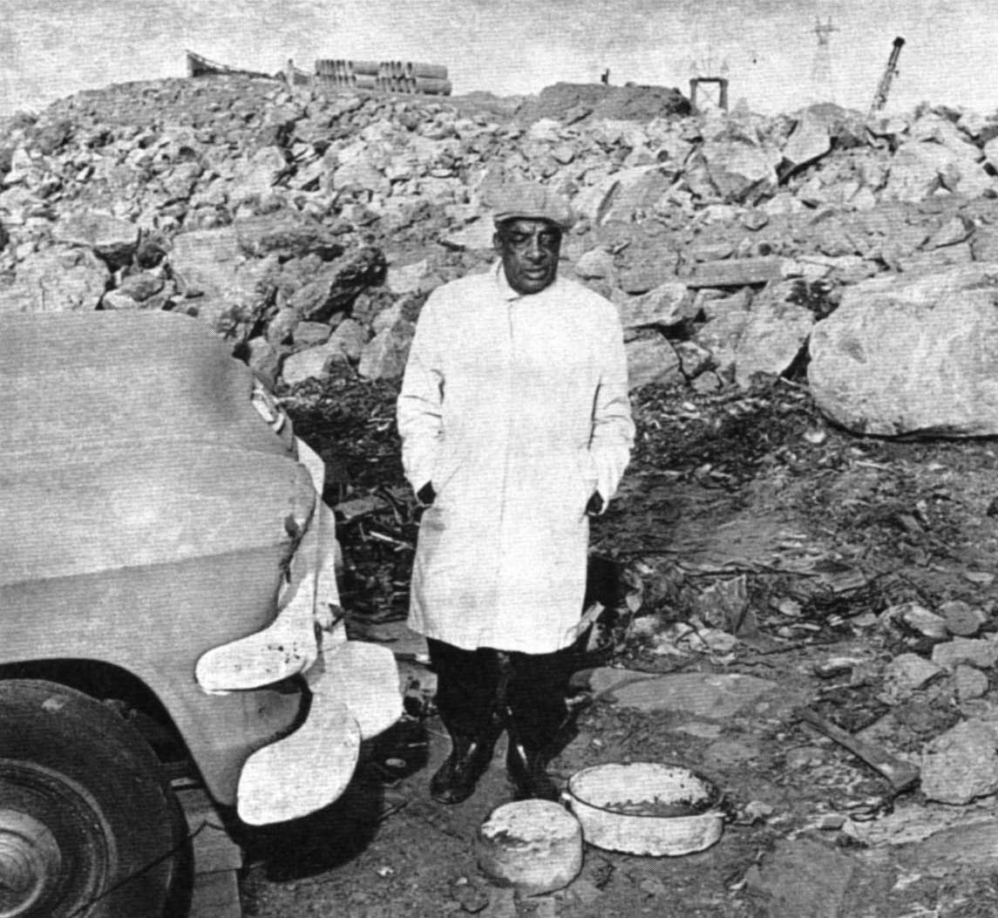
Presentation slide by Patricia Clark
Photo Source: (unless otherwise indicated)
The Spirit of Africville, (D. Clairmont et al) 1992
Get back to question 6

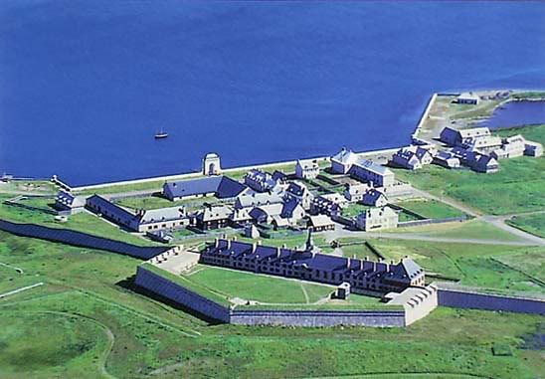
Get back to question 12

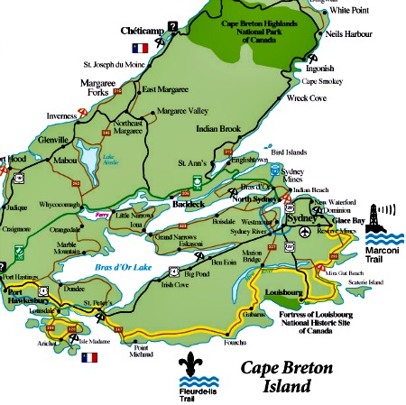
Get back to question 12

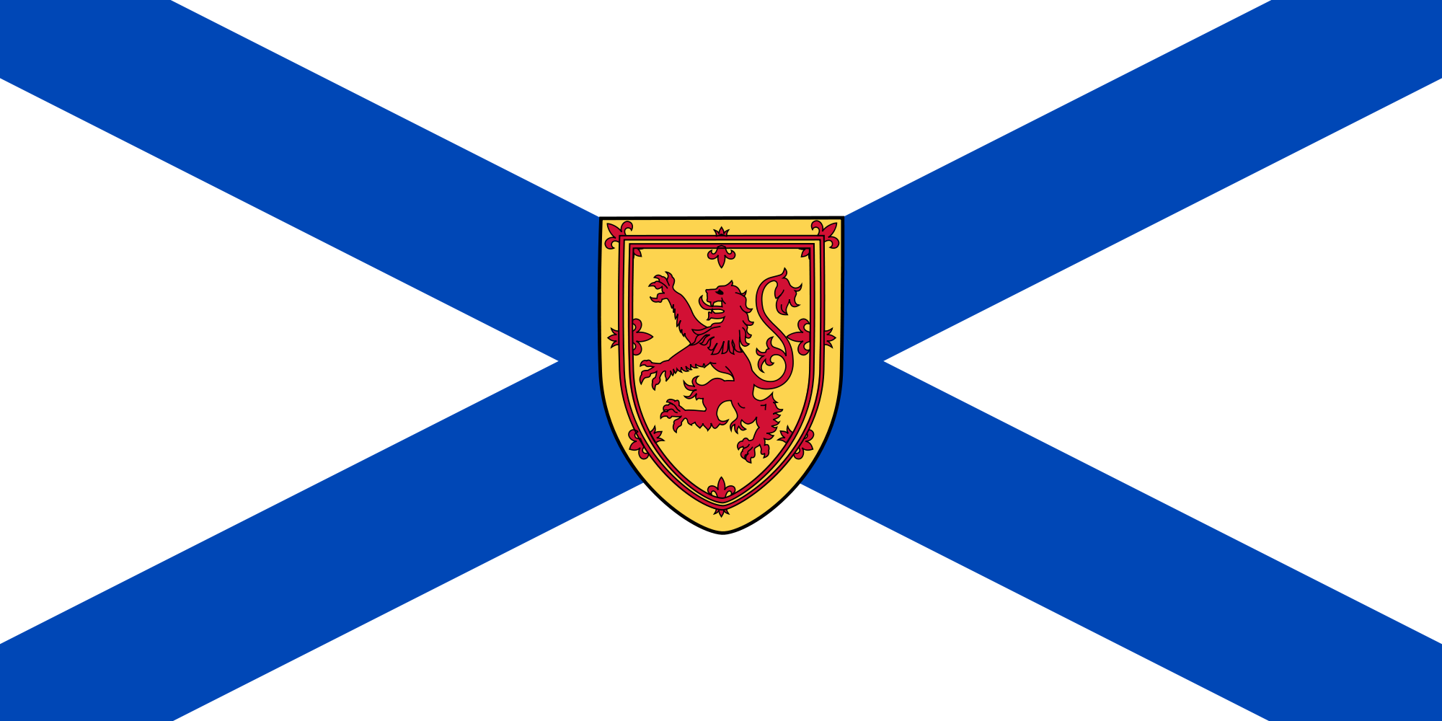

Get back to question 13

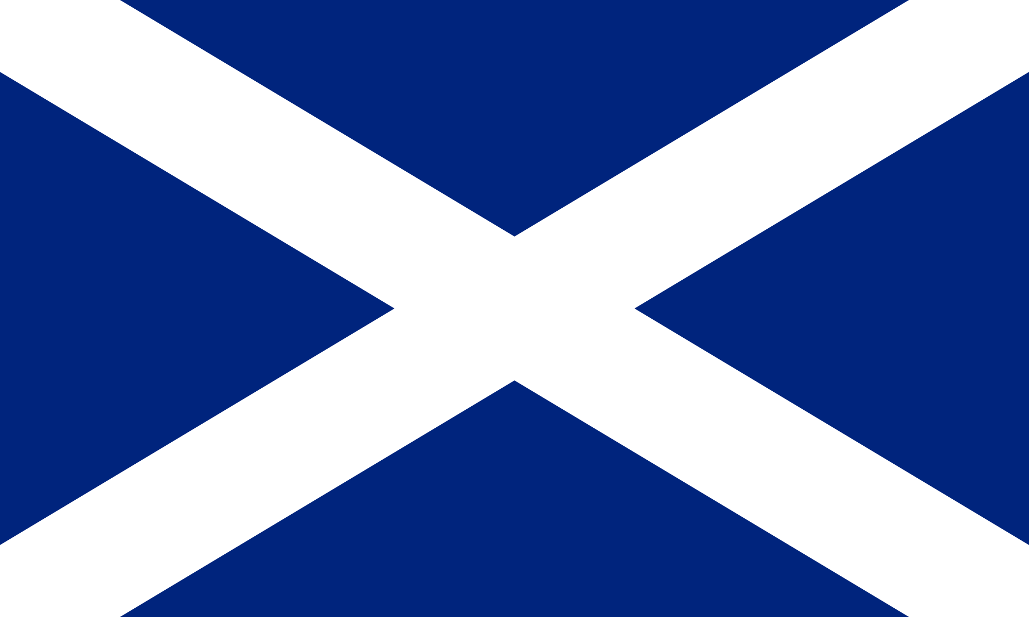 Get back to question 14

Stephen McNeil, Premier of Nova Scotia.
Get back to question 15

